

**PRATIBHA INSTITUTE OF BUSINESS MANAGEMENT**

**CHINCHWAD, PUNE-411019**

**2022-23**

**PROJECT REPORT**

**ON**

**Medical Reports - Online Consultation**

**BY**

**Dipesh Patil**

**Course: Master’s in Computer Application**

**(1st Year: 2nd Semester)**

**Roll No.:22025**

Under guidance of

**Prof. Kalyansing Patil.**

TITLE PAGE

**Medical Reports - Online Consultation**

**DECLARATION**

I hereby declare that the project titled **Medical Reports - Online Consultation** has been completed by me under the guidance of **Prof. Kalyansing Patil** and is being submitted in partial fulfilment for the award of degree Master in Computer Application by **Savitribai** **Phule Pune University** during the Academic Year 2023-24. This project is based on my knowledge and has not been submitted anywhere else.

**Dipesh Sanjay Patil**

**ACKNOWLEDGEMENT**

It is my proud privilege to express my profound gratitude to the entire management of Pratibha Institute of Business Management and teachers at the institute for providing me with the opportunity to avail the excellent facilities and infrastructure of the institute. The knowledge and values inculcated have proved to be of immense help to my career.

I am grateful to every teaching / non-teaching staff member of MCA department of PIBMfor their astute guidance, constant encouragement, sincere support for this project work.

I express my sincere gratitude to **Prof.** **Kalyansing Patil** for their inspiration, constructive suggestion, mastermind analysis and affectionate guidance in my work, without which this project work completion would have been impossible for me. Sincere thanks to all my seniors and colleagues at the college for their support and assistance throughout the project.

I would like to thank all the faculties for providing me with an opportunity to pursue my industrial training, as it is an important part of the MCA course.

I feel proud and privileged in expressing my deep sense of gratitude to all those who have helped me in presenting this assignment. I would be failing in my endeavor if I do not place my acknowledgement.

**Index**

|  |  |  |
| --- | --- | --- |
| **Sr.no** | **Topic Name** | **Page no.** |
| **1.** | **INTRODUCTION**   * 1. Introduction   2. Objective   3. Existing System and Need for System | **6** |
| **2** | **PROPOSED SYSTEM**  2.1 Overview  2.2 Scope of the system  2.3 Module specifications  2.4 Detail Description of Technology Used  2.5 User Characteristics  2.6 Project Requirements | **8** |
| **3** | **SYSTEM ANALYSIS & DESIGN**  System Requirements (Functional and Non-Functional requirements)  3.1 Entity Relationship Diagram (ERD)  3.2 Class Diagram  3.3 Use Case Diagram  3.4 Sequence Diagram  3.5 Activity Diagram  3.6 Sample Input and Output Screens  3.7 Table specifications | **11** |
| **4** | **USER MANUAL** | **25** |
| **5** | **LIMITATIONS OF FUTURE ENHANCEMENTS** | **26** |
| **6** | **CONCLUSION** | **27** |
| **7** | **BIBLIOGRAPHY** | **28** |
| **8** | **ANNEXURES:**  **ANNEXURE 1: USER INTERFACE SCREENS**  **ANNEXURE 2: OUTPUT REPORTS WITH DATA (if any)**  **ANNEXURE 3: SAMPLE PROGRAM CODE / Project Demo** | **29** |

**1.1 INTRODUCTION: -**

Medical Reports - Online Consultation is a web application Developed in PHP. It helps patients to get opinion on their medical reports (ECG, Blood Test).

Medical Reports - Online Consultation saves the users time and money. They need not to reach doctors for normal report consultation.

Medical Reports - Online Consultation provides reports in simple language which users can easily understand.

**1.2 OBJECTIVE: -**

The main objective of Online medical consultation refers to providing health care services by the health care professionals using digital technology for diagnosing, treating, and preventing diseases or any injuries. [It is the best form of virtual consultations exclusive for the benefit of patients where distance can be a constraint](https://www.tataaia.com/blogs/life-insurance/what-is-online-medical-consultation.html).

Online consultations are where you fill in an online form or speak to someone online about a health issue. [Depending on the diagnosis, medical therapy may be prescribed](https://medical-dictionary.thefreedictionary.com/virtual+consultation)

**1.3 EXISTING SYSTEM**: -

In the existing system all the works are done sometimes manually and time taking. In this existing system Currently, patients need to take an appointment with doctor to get consultation on medical reports. This is time-consuming and costly.

**Drawbacks of existing system: -**

* It is time consuming process.
* Also, in some case it doesn’t go according to conditions.
* It is difficult to understand the terms related with healthcare.
* We need to have detail knowledge about the disease we are suffering from.

**Need For the System:**

* To change the offline process of medical consultation which is time consuming and costly.
* This system provides user friendly interface and better consultation with simple consultation report in short time.

**PROPOSED SYSTEM: -**

**2.1 OVERVIEW: -**

This project is related with the computerized **Medical Reports - Online Consultation** which has only two level -

* Doctor Level- Doctor Operators to provide review.
* User Level- Customer Operator.
  1. **PROBLEM STATEMENT:**

The case study titled is web application for the medical report consultation. This application allows user to upload medical reports for consultation with report details like report images, symptoms, report date etc. We need to maintain received reports and review carefully. Doctors review the report details and create the report review in simple and understandable format with suggestions.

End Users:

User/Patients: To get Consultation on medical reports user uploads reports on website.

Doctors: Reviews reports and creates report review.

**2.3 PRODUCT OVERVIEW:**

The case study titled is web application for the medical report consultation. This application allows user to upload medical reports for consultation with report details like report images, symptoms, report.

**2.4 OBJECTIVE OF SYSTEM:**

* The main objective of the Medical Reports - Online Consultation is to provide consultation on medical reports in low cost and save the time of patients.
* Patients can easily upload reports on portal. Simple and Clean user-friendly User Interface.
* It Manages Patient information, Medical Reports, Doctors information and Login credentials securely.
* The project is built for three users Admin, Patients, Doctors/Specialists. All users have specific access as per their need.

**2.5 SCOPE OF THE SYSTEM:**

* Medical Reports - Online Consultation is web-based applications which users can easily access in any web browser using URL.
* Users can easily create an account and upload medical reports (ECG, Blood Test). After specialist’s review users can download report in pdf format.
* Doctors can easily monitor the reports received and after reviewing the can create a simple report for user in doctor’s portal.
* Admin can monitor the Users, Doctors, Reports, and Transactions in admin portal.

**2.6 Module Specification:**

* **User Module**
* **Doctor Module**

**OPERATING ENVIRONMENT:**

**Software Requirement: -**

* Operating System: Windows 7/8/10
* Front End: HTML, CSS, Bootstrap, Tailwind CSS
* Back End: PHP, jQuery.
* Database: MySQL Server (XAMPP)
* Web Browsers: Chrome, Firefox, Internet Explorer.

**Hardware Requirements: -**

* Ram: 2 GB
* Hard Disk: Minimum 512MB (or more)

**SYSTEM ANALYSIS & DESIGN**

**3.1 ENTITY RELATIONSHIP DIAGRAM**

**3.2 CLASS DIAGRAM**

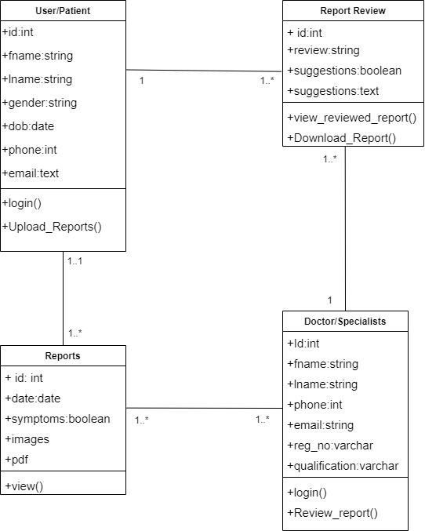

**3.3 USE CASE DIAGRAM**

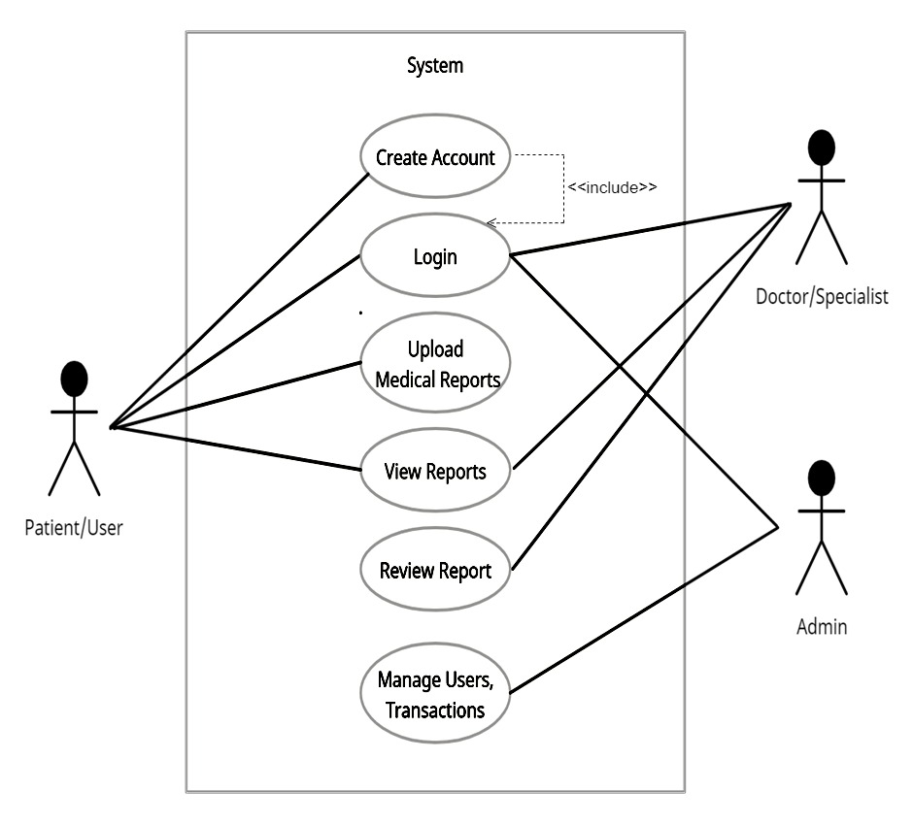

**3.4 SEQUENCE DIAGRAM**

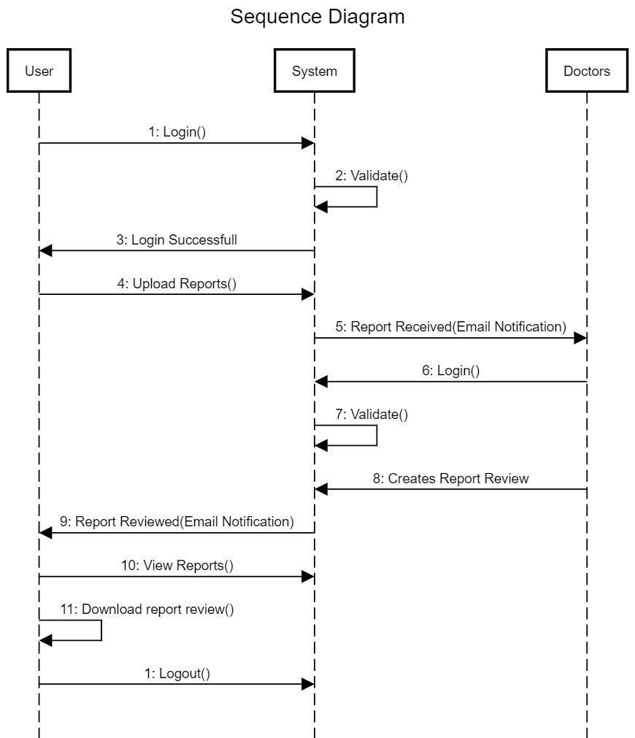

* 1. 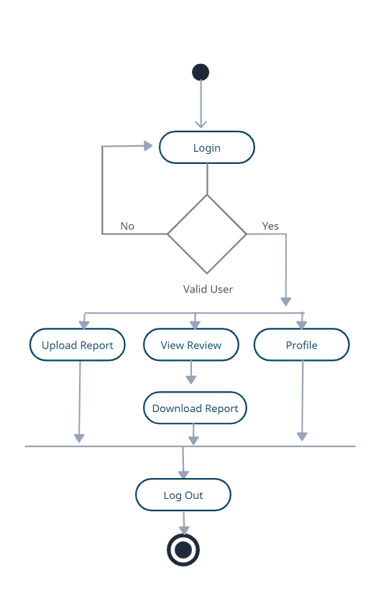**ACTIVITY DIAGRAM( USER/PATIENT)**
  2. **ACTIVITY DIAGRAM( DOCTOR/SPECIALIST)**

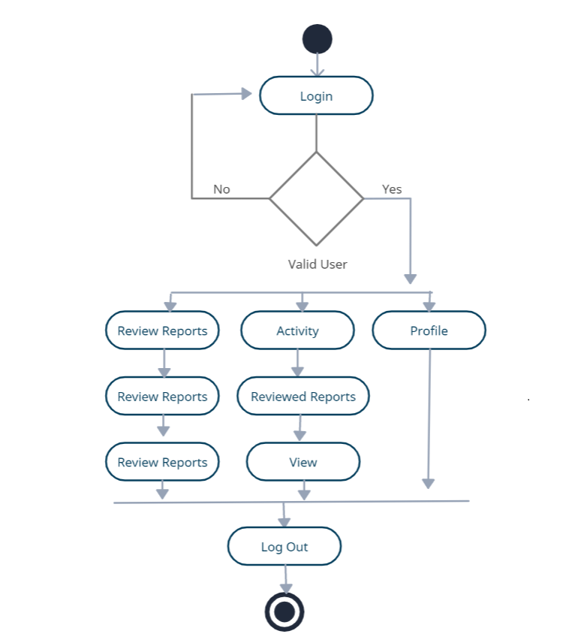

* 1. **Input Screens (User)**
* **Home Screen for User:**

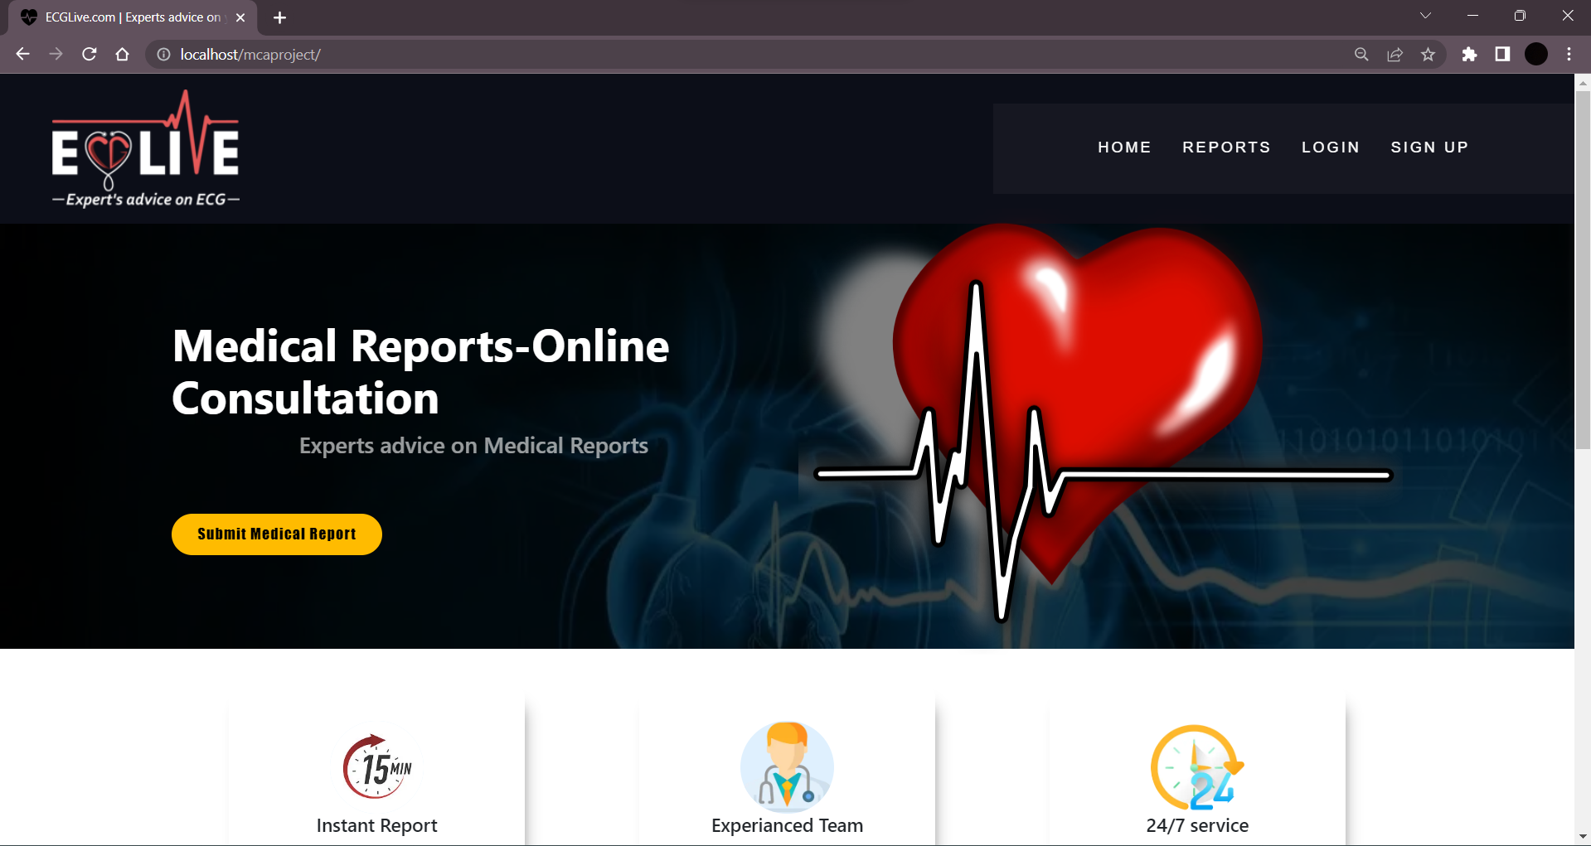

* **User login Screen:**

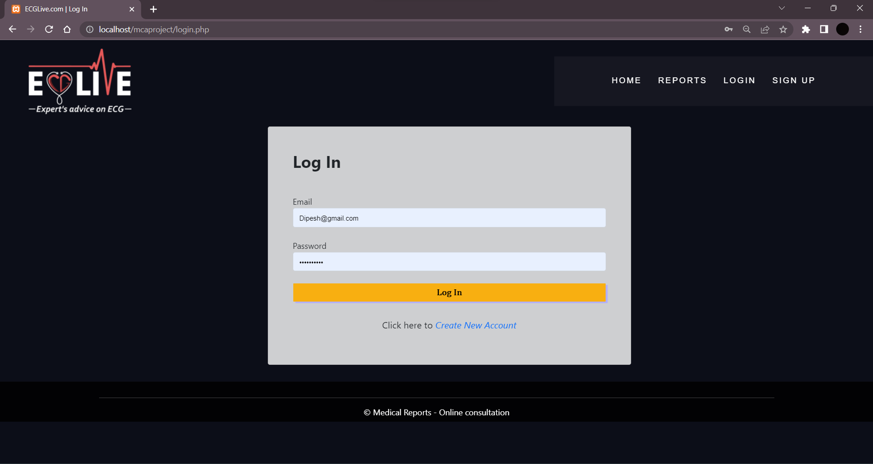

* **New User Registeration Tab:**

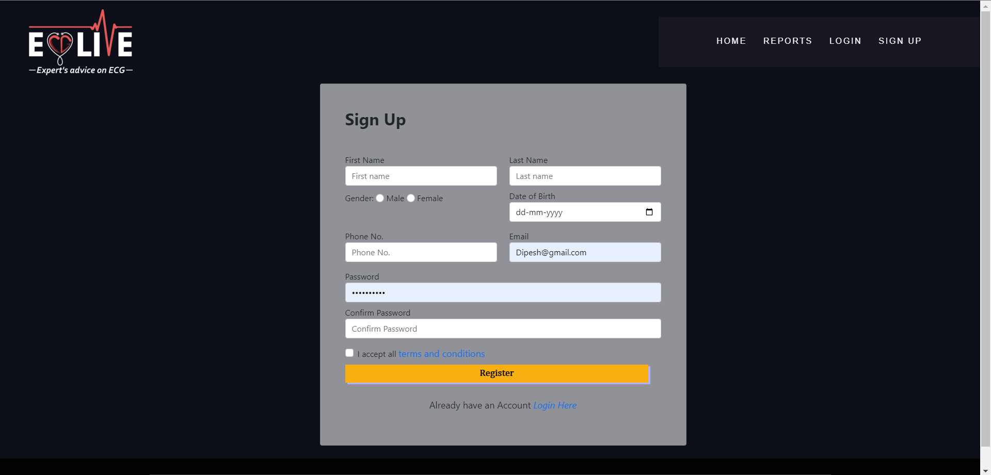

* **To Upload Report and details Tab:**

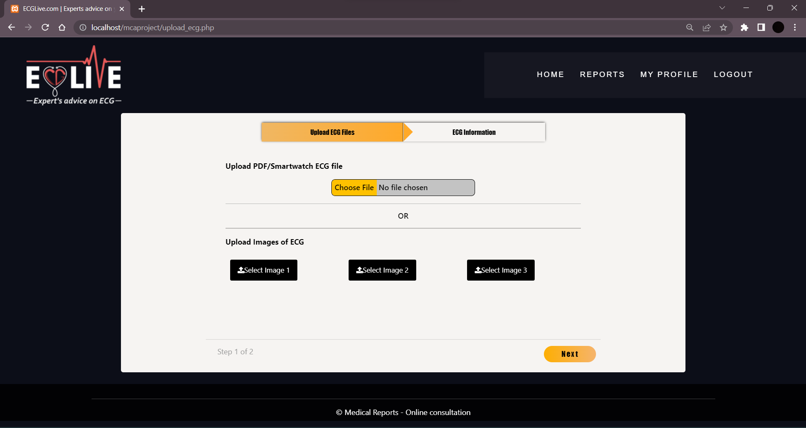

* **Sample How we can upload document:**

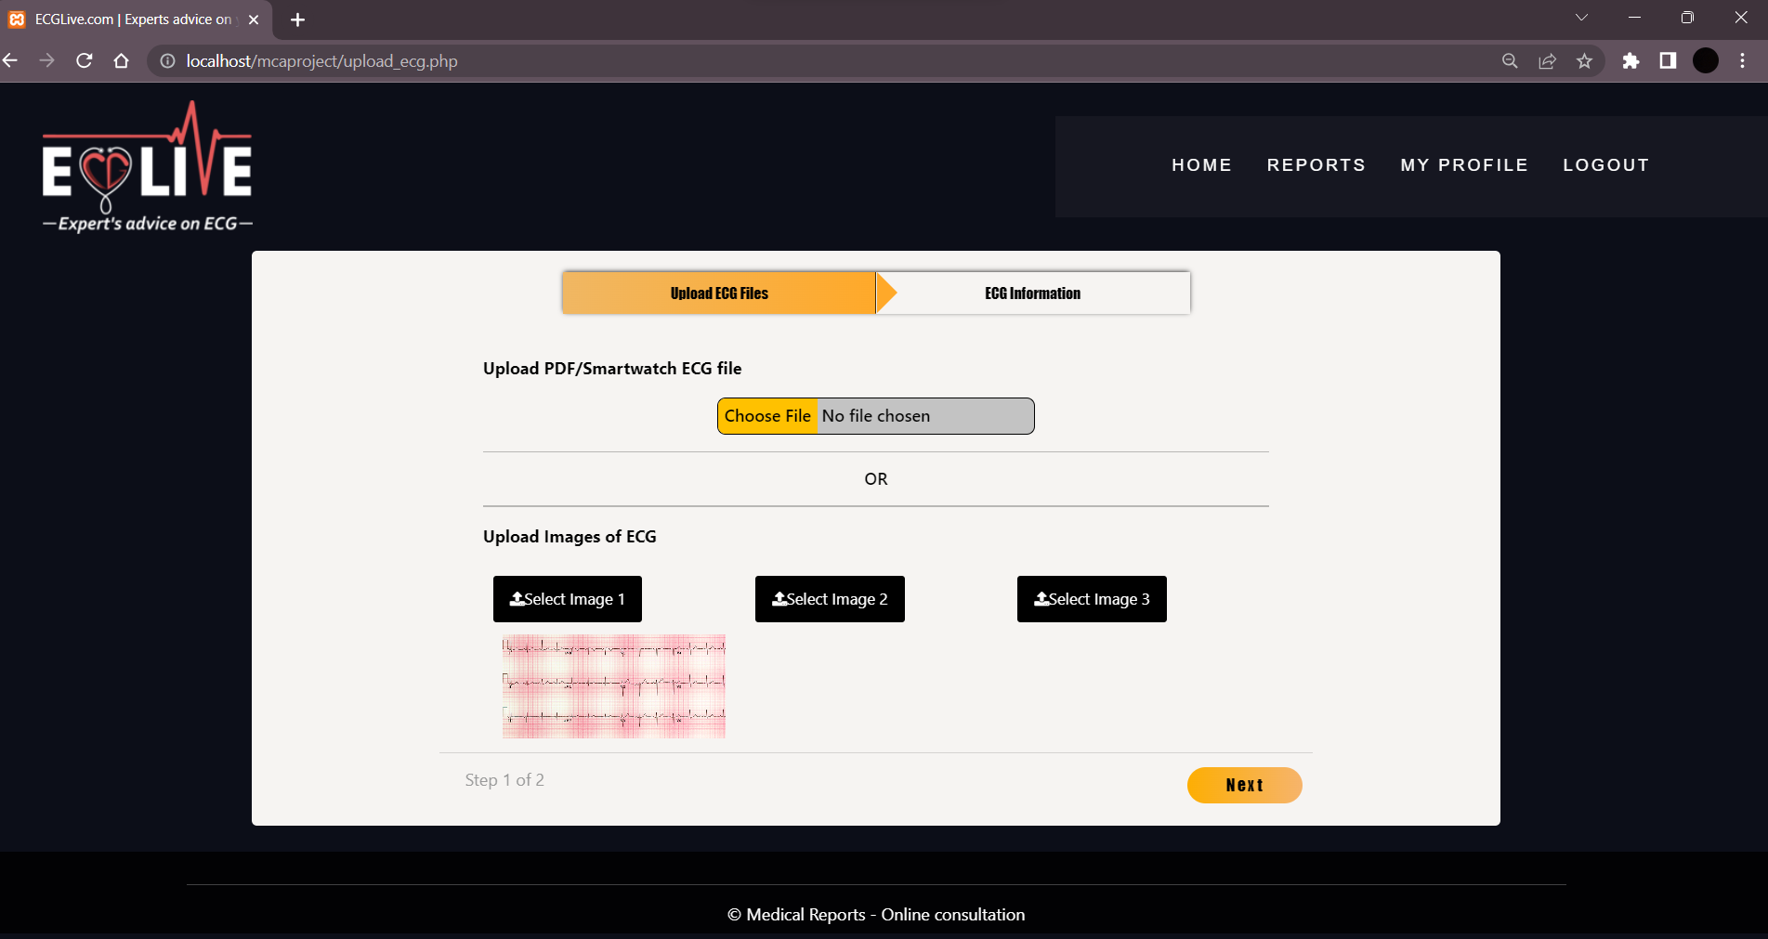

* **To Extra details this tab is used:**

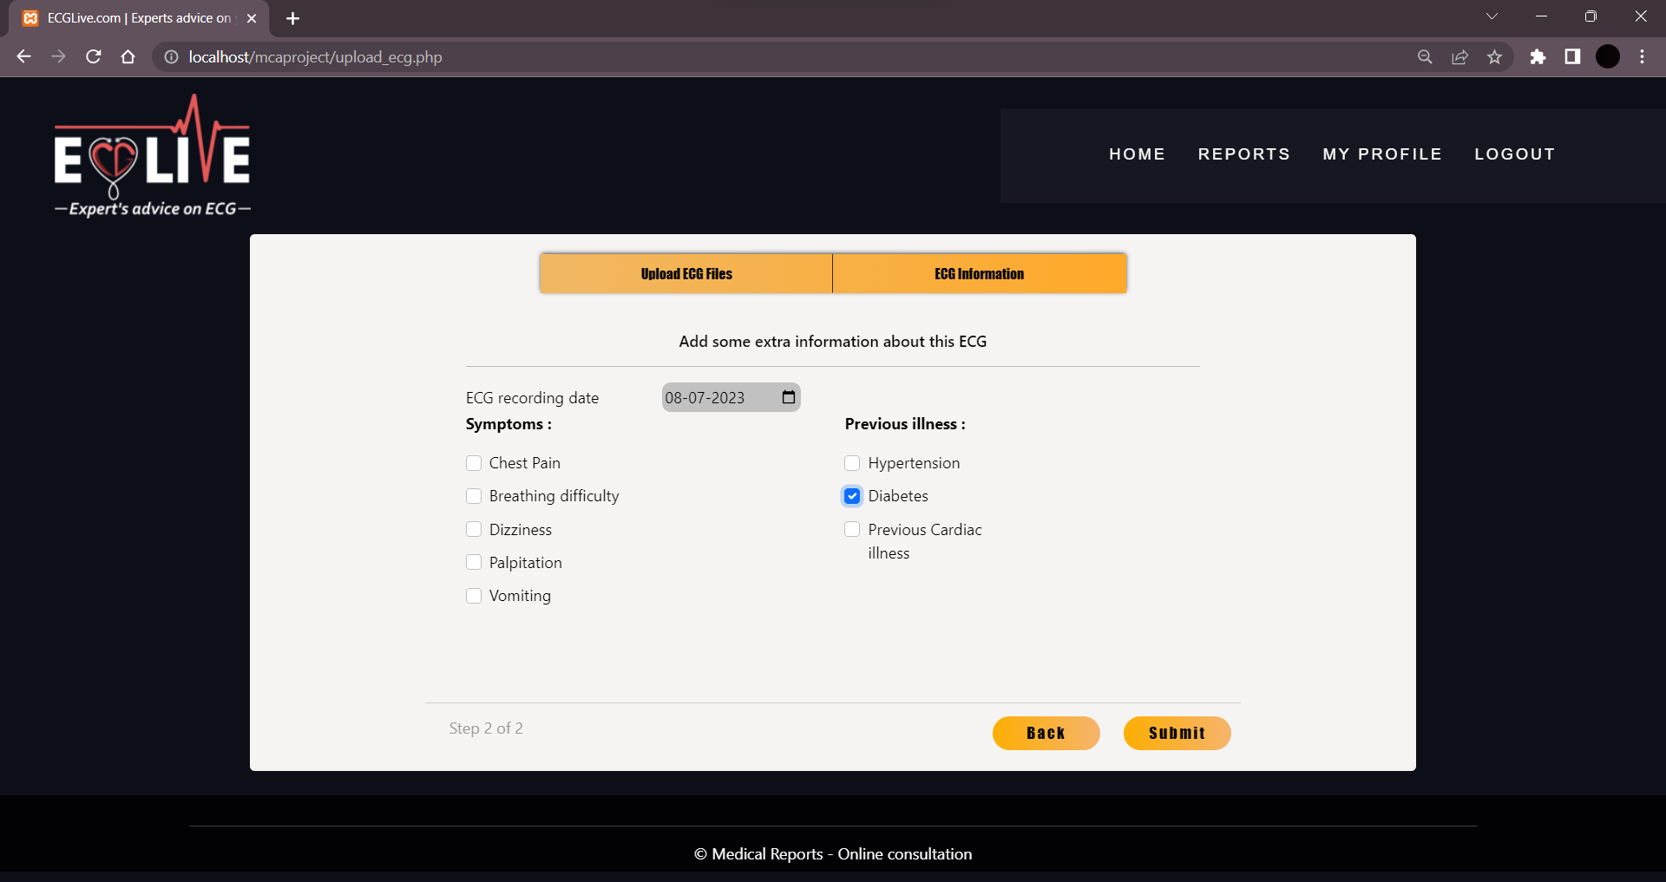

* **Need to upload ECG PDF or Images:**

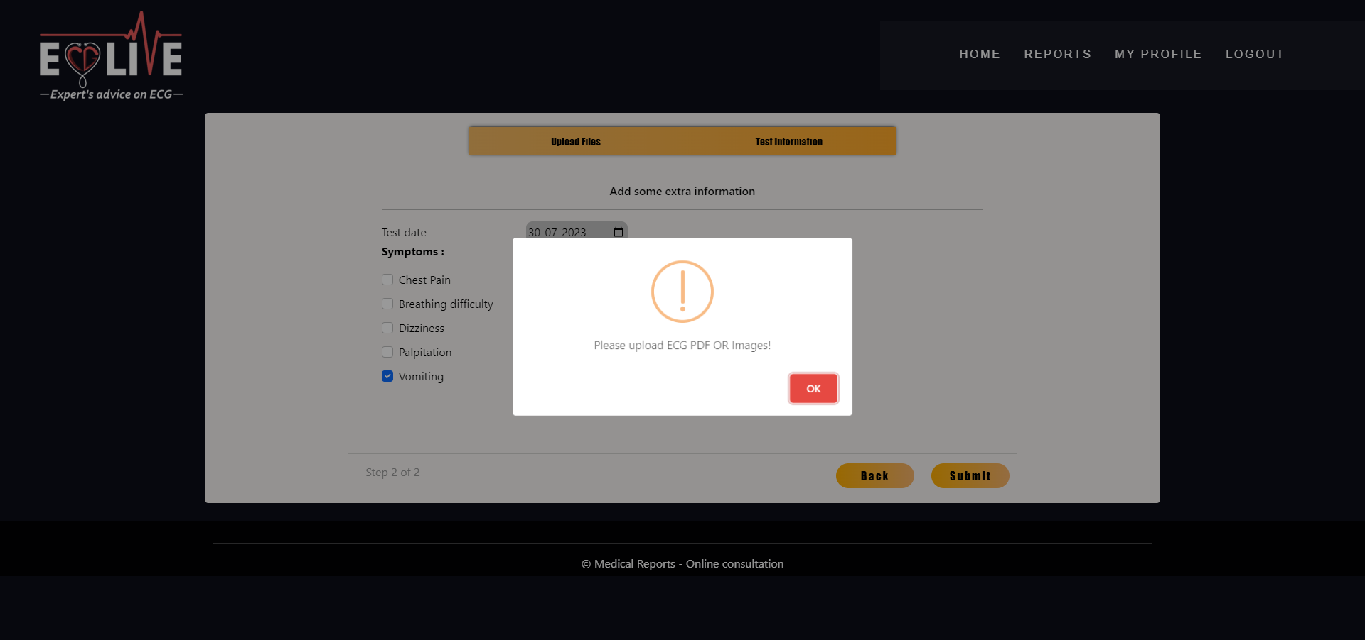

* **After Clicking Submit button this scrren appears:**

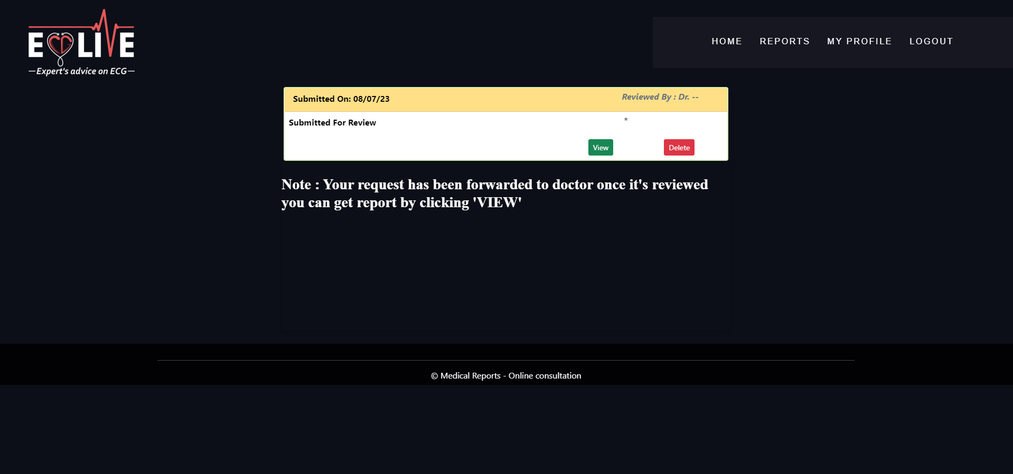

**Input Screens (Doctor):**

* **Login Screen for Doctor:**

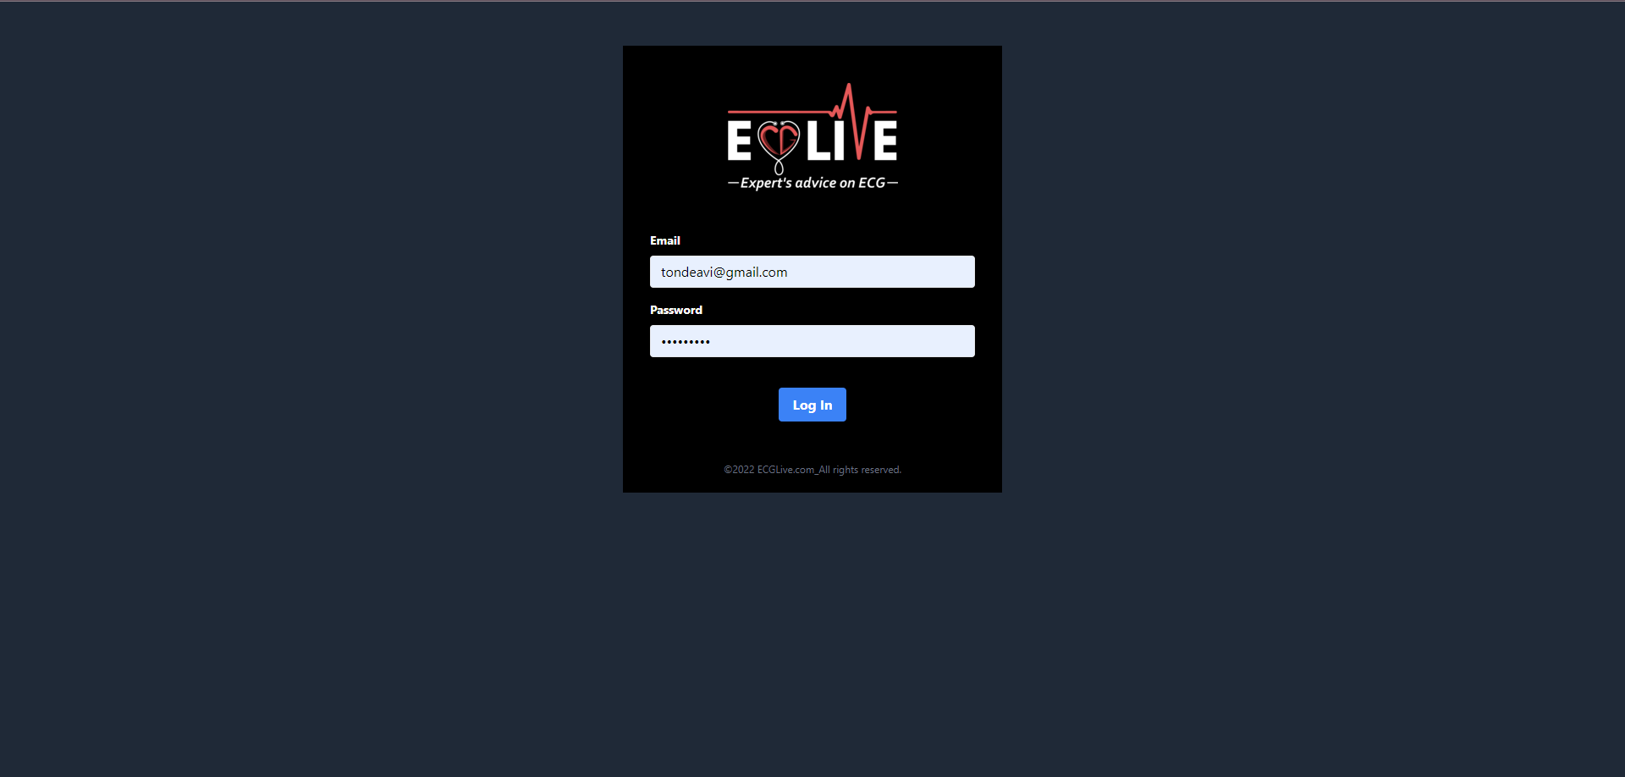

* **User Home Page after login screen:**

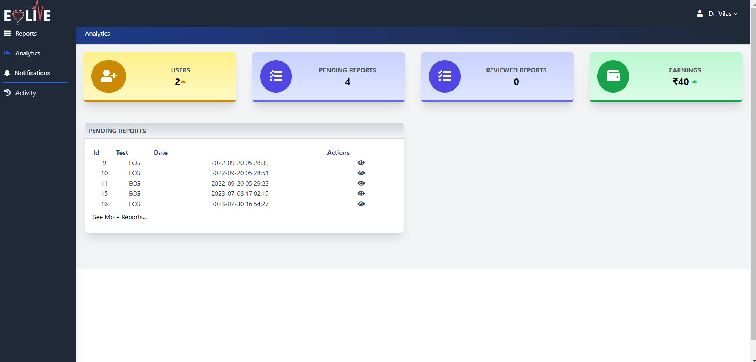

* **After Clicking eye button after report doctor can view the report and provide review for it:**

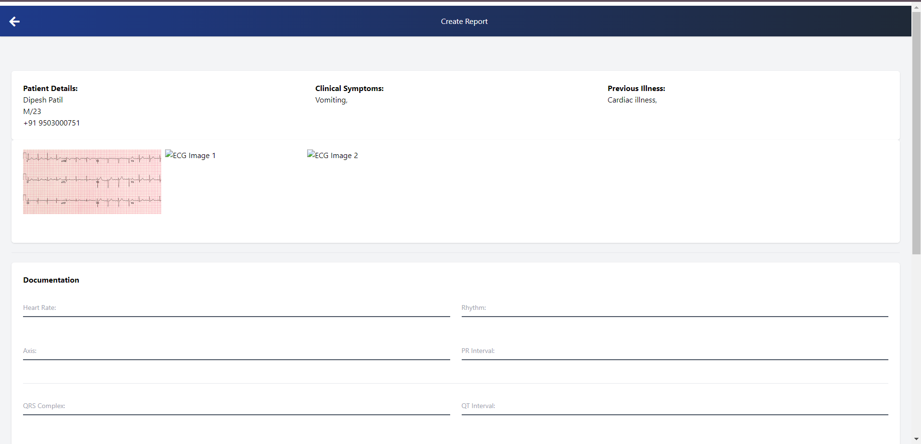

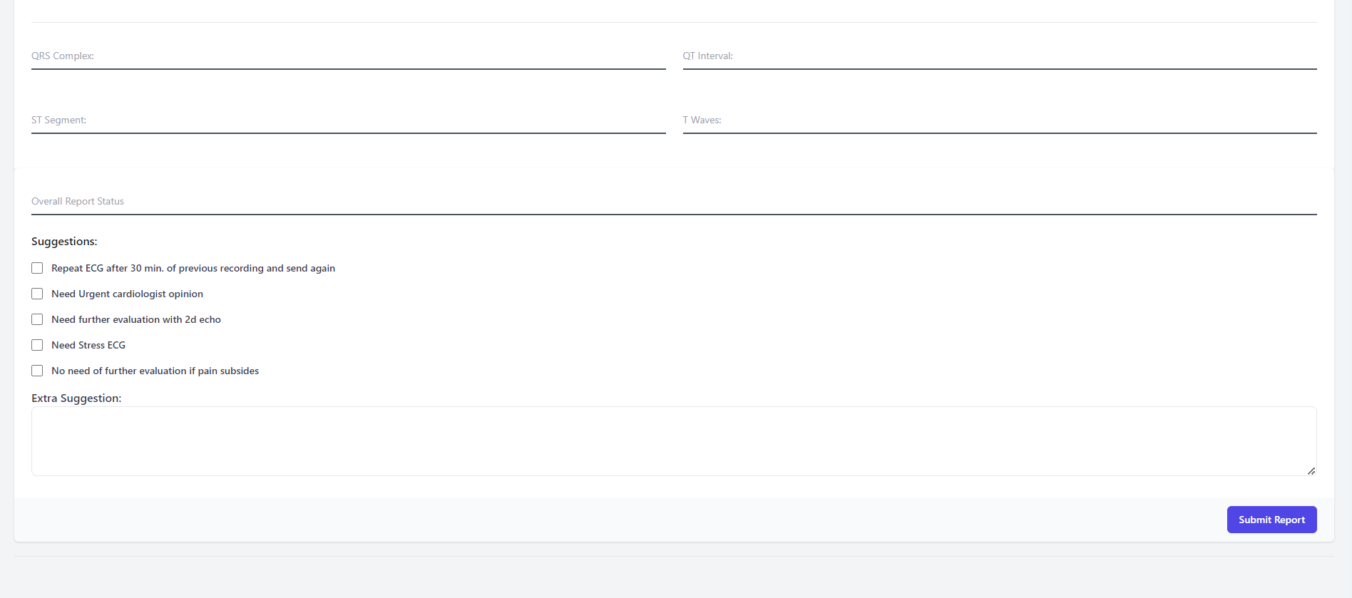

**TABLE SPECIFICATIONS**

**Users:**

|  |  |  |
| --- | --- | --- |
| **Name** | **Data Type** | **Constraints** |
| userid | Int (10) | Primary key |
| first_name | Varchar (20) | Not null |
| last_name | Varchar (20) | Not null |
| Gender | Varchar (10) | Not null |
| Dob | date | Not null |
| Phone | Varchar (15) | Not null |
| email | Varchar (55) | unique |
| password | Varchar (99) | Not null |

**Reports:**

|  |  |  |
| --- | --- | --- |
| **Name** | **Data Type** | **Constraints** |
| userid | Int(10) | Foreign key |
| reportid | Int(10) | Primary key |
| Report_date | date | Not_null |
| symptoms | Varchar(55) | - |
| Pre_illness | Varchar(50) |  |
| pdf | Varchar(55) | - |
| images | Varchar(99) | - |
| status | Varchar(15) | Not_null |
| Upload_date | datetime | Not_null |

**Doctors:**

|  |  |  |
| --- | --- | --- |
| **Name** | **Data Type** | **Constraints** |
| dtid | int(3) | primary key |
| fname | int(10) | not_null |
| lname | date | not_null |
| qualification | varchar(55) | not_null |
| phone | varchar(55) | not_null |
| email | varchar(99) | unique |
| password | varchar(15) | not_null |

**Review report:**

|  |  |  |
| --- | --- | --- |
| **Name** | **Data Type** | **Constraints** |
| rr_id | int(3) | primary key |
| Report_id | int(10) | Foreign key |
| userid | date | Foreign key |
| dtid | varchar(55) | Foreign key |
| R_review | varchar(55) | not_null |
| Suggestions_check | varchar(99) | unique |
| Suggestions_text | varchar(15) | not_null |

**USER MANUAL:**

1.Home Page: The user gets into dashboard from where they can login into system or if user is new then he/she can sign-up into the system, also can see the reports and can submit the report for review.

2.Doctor Login: Enter User Name and Password→ Click on Login Button to log in.

3.Doctor Dashboard: The dashboard is the front page of the Doctor UI. It provides convenient shortcuts for common management tasks, some server information, and Review user which are using this system, also review patients report and provide accurate review for their medical reports.

4.user Login: Click user Login Button on Homepage →Enter User Name and Password→ Click on Login Button to log in.

**LIMITATIONS AND FUTURE ENHANCEMENT**

**Limitations: -**

* Due to lack of time, we could not offer more facilities.
* Also, we have not restricted and user control.
* Our system is not including any doctor registrations facilities.

**Future Enhancement: -**

1. We can restrict doctor and user control by creating separate admin login from which user can easily control or management purpose this better option.
2. Also, we can provide best doctors or hospital details from where patient can easily take treatment on their medical problem.
3. We are going to add payment method for now their no payment is required for adding more features need some fund ,their also be monthly/yearly basis plan that can patient easily do payment.

**Conclusion**

* This Medical Report - Online Consultation is a web-based application that helps patients to get opinion on their medical reports (ECG, Blood Test) without visiting doctor.
* The proposed application aims to create a user-friendly graphical user interface and features to overcome the drawbacks in existing system of Consultation. This system is very reliable and flexible from all aspects, so new features and modules can be easily integrated into the system in future.
* This application is developed using CSS as part of front end and PHP, MySQL for backend. The goals are that are achieved by the software are:
* Optimum utilization of resources.
* Efficient management of records.
* Simplification of the operations.
* User friendly
* Portable and flexible for further enhancement.

**Bibliography**

**Search Engine:** <https://www.google.com/>

**Websites:**

* <https://www.w3schools.com>
* <https://getbootstrap.com>
* <https://tailwindcss.com/docs>

**Books Referred:**

1. HTML & CSS: The Complete Reference, Fifth Edition by Thomas A. Powell.
2. [Learning Web Design: A Beginner’s Guide to HTML, CSS, JavaScript, and Web Graphics](https://www.amazon.com/gp/product/1449319270/ref=as_li_ss_tl?ie=UTF8&camp=1789&creative=390957&creativeASIN=1449319270&linkCode=as2&tag=tripwiremagaz-20) (2012)

**ANNEXURES:**

**ANNEXURE 1: SAMPLE PROGRAM CODE / Project Demo:**

<?php

  require 'inc/dbconn.php'

?>

<!DOCTYPE html>

<html lang="en">

<head>

  <meta charset="UTF-8">

  <meta http-equiv="X-UA-Compatible" content="IE=edge">

  <meta name="viewport" content="width=device-width, initial-scale=1,user-scalable=no">

  <meta name="title" content="Online ECG Interpretation | ECG Reading | ECGLive.com">

  <meta name="description" content="Upload your ECG Photos or PDF on ecglive.com. Our Experts will analyze your ECG within 15 min  and provide report.">

  <meta name="keywords" content="Online ECG Interpretation, ECG reading, ecglive, ecglive.com, Experts advice on ecg, online second opinion on ecg">

  <meta name="robots" content="index, follow">

  <meta http-equiv="Content-Type" content="text/html; charset=utf-8">

  <meta name="language" content="English">

    <title>ECGLive.com | Experts advice on your ECG</title>

  <!-- Bootstrap 5 CDN Link -->

  <script async src="https://ajax.googleapis.com/ajax/libs/jquery/3.6.0/jquery.min.js"></script>

  <link href="https://cdn.jsdelivr.net/npm/bootstrap@5.0.2/dist/css/bootstrap.min.css" rel="stylesheet">

  <link href="https://maxcdn.bootstrapcdn.com/font-awesome/4.7.0/css/font-awesome.min.css" rel="stylesheet">

  <link rel="stylesheet" href="./assets/styles/style.css" class="stylesheet">

  <link rel="stylesheet" href="./assets/styles/footer.css" class="stylesheet">

  <link rel="stylesheet" href="./assets/styles/reviews.css" class="stylesheet">

  <link rel="stylesheet" href="./assets/styles/team.css" class="stylesheet">

  <link rel="stylesheet" href="./assets/styles/features.css" class="stylesheet">

  <link rel="apple-touch-icon" sizes="180x180" href="fevicon/apple-touch-icon.png">

<link rel="icon" type="image/png" sizes="32x32" href="fevicon/favicon-32x32.png">

<link rel="icon" type="image/png" sizes="16x16" href="fevicon/favicon-16x16.png">

<link rel="manifest" href="fevicon/site.webmanifest">

  <style>

    .cascading-right {

      margin-right: -50px;

    }

    h2 {

    text-align: center;

    margin-bottom: 40px;

    }

    @media (max-width: 991.98px) {

      .cascading-right {

        margin-right: 0;

      }

    }

  </style>

</head>

<body>

<?php

  session_start();

  require './inc/header.php';

?>

<div class="bgimg">

<section id="hero" class="d-flex align-items-center ">

  <div class="container ">

      <div class="row">

        <div class="col-lg-6 d-flex flex-column justify-content-center pt-4 pt-lg-0 order-2 order-lg-1" data-aos="fade-up" data-aos-delay="200">

          <h1>Medical Reports-Online Consultation</h1>

          <h2>Experts advice on Medical Reports</h2>

          <div class="d-flex justify-content-center justify-content-lg-start">

            <a href="select_report.php" class="btn-get-started scrollto">Submit Medical Report</a>

          </div>

        </div>

        <div class="col-lg-6 order-1 order-lg-2 hero-img" data-aos="zoom-in" data-aos-delay="200">

          <img src="assets/images/ECG-heart.svg" class="img-fluid animated" alt="">

       </div>

      </div>

  </div>

</section>

</div>

<main class="mainbg">

  <div class="container">

    <?php

      include('./inc/features.php');

       include('./inc/about.php');

       //include('./inc/team.php');

       //include('./inc/pricing.php');

       include('./inc/customerreview.php');

    ?>

  </div>

</main>

<script async src="assets/scripts/razorpay.js"></script>

<script async src="https://checkout.razorpay.com/v1/checkout.js"></script>

<?php

require './inc/footer.php';

?>

**ANNEXURE 2: OUTPUT REPORTS WITH DATA (if any):**

* **Output Screens for User:**

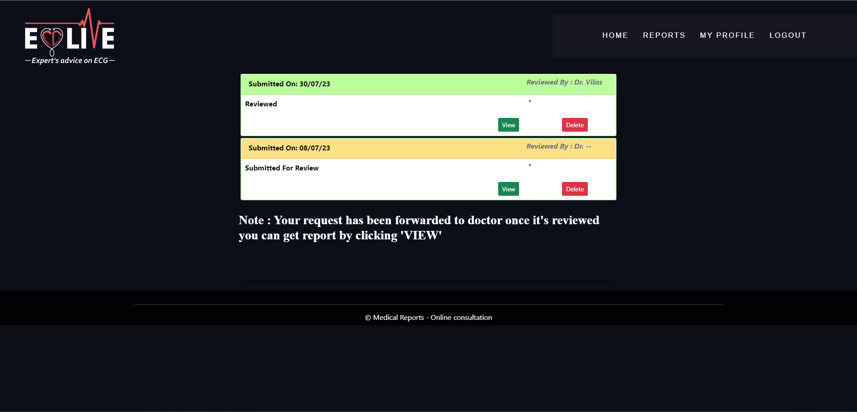

* **After the report is reviewd by doctor , we can report by clicking view:**

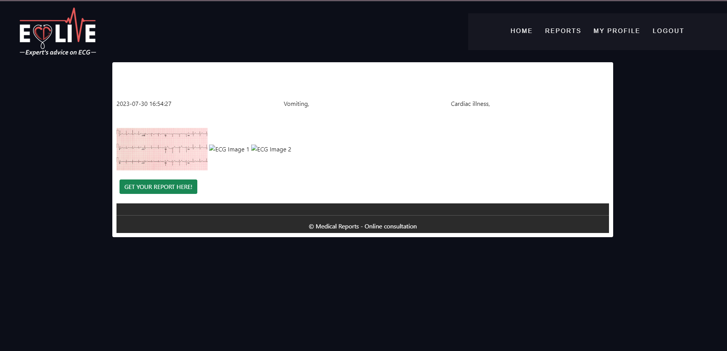

* **By clicking “GET YOUR REPORT HERE” button:**

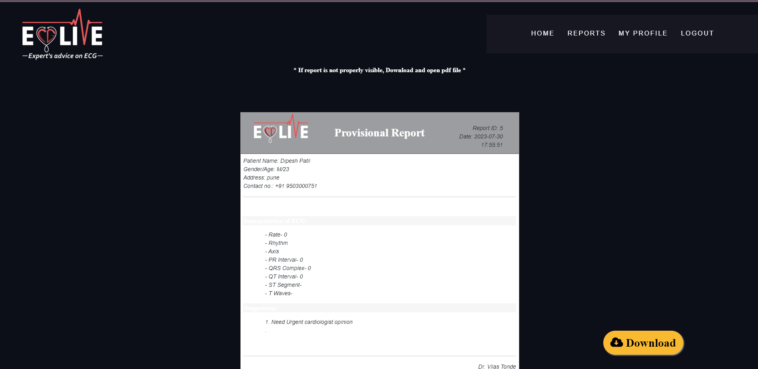

* **By clicking download button User can download the report:**

